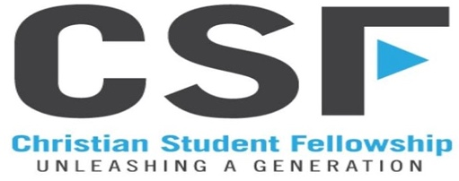
University of South Dakota Full Time Campus Minister

Christian Student Fellowship (CSF) is seeking a full time campus minister to help launch a new campus ministry at the University of South Dakota in Vermillion. This person will work alongside another full time intern, and core group of student leaders to lead the ministry at USD in introducing students to Jesus, discipling them to live like Jesus, and unleashing them for Jesus across their campus and around the world for Jesus.

We believe this includes the following:
- Introducing students into a Kingdom centered relationship with God through Jesus.
- Challenging and encouraging students to grow in their Christian faith journey.
- Equipping students to engage others as they introduce them to a life of following Jesus.
- Cultivating an environment and schedule that allows people to belong and engage others as they grow together.

Qualifications:
- A clear testimony of faith in Jesus Christ, and a growing relationship in and with Him.
- An ability to effectively lead alongside a team toward the goals and vision they develop together.
- An outgoing approach and willingness to invest in people.
- An ability to communicate in both the corporate and individual settings.
- A willingness to live missionally to the group we are ministering to and with.
- Agree with the statement of faith of CSF. CSF Statement of Faith

Position Overview:
- This is a full time position. Salary is $40,000 - $50,000 depending on experience.
- Staff raise 50% of their salary.

Position Needs:
- An ability to identify, raise up, mentor, and train student leaders.
- A passion for small group and one-on-one discipleship.
- A self-starter.
- Flexible and open to change, as things are different every year.
- A people person, who can meet new people and is not afraid to be outgoing and start conversations.

Interested people can send a resume to CSF Director Justin Raulston at justin@csfneb.org and can fill out an online application at: CSF Application

